Sri Lanka Institute of Information Technology



**Enterprise Standards and Best Practices for IT Infrastructure**

**Creating Windows and Linux AMI instance using AWS**

**Lab 01**

**Reg No: - IT13074296**

**Name: -Asurasinghe A.R.H.S**

**Batch: - ITWE**

**01 Creating Windows Instance using AWS account.**

Step 01

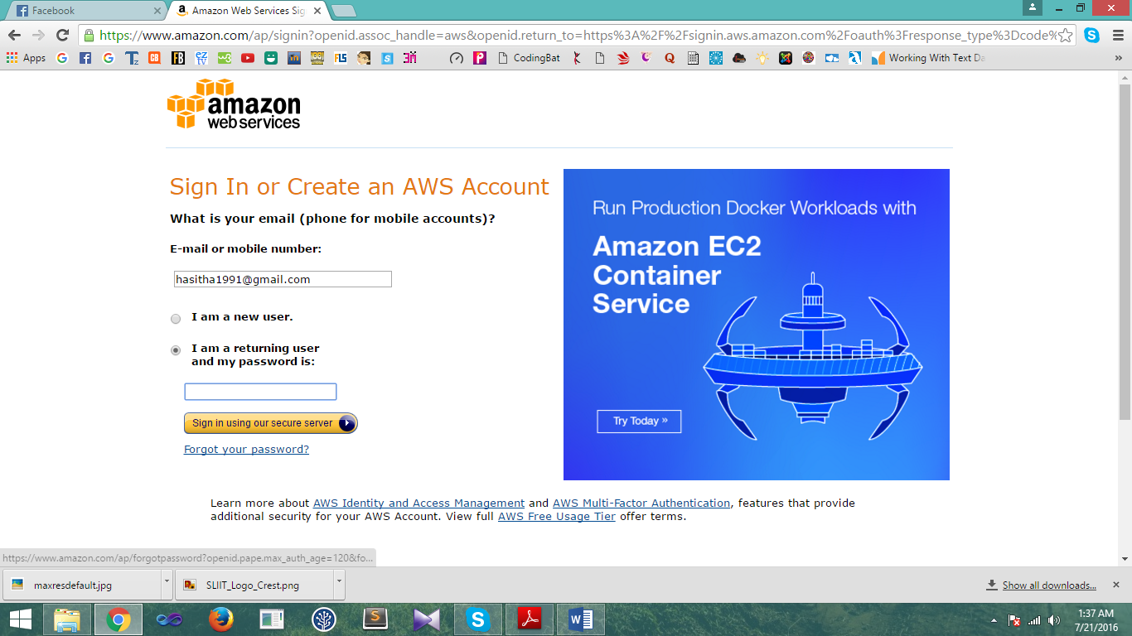User has to successfully login to the AWS account.

Step 02

Select and click the EC2 link.

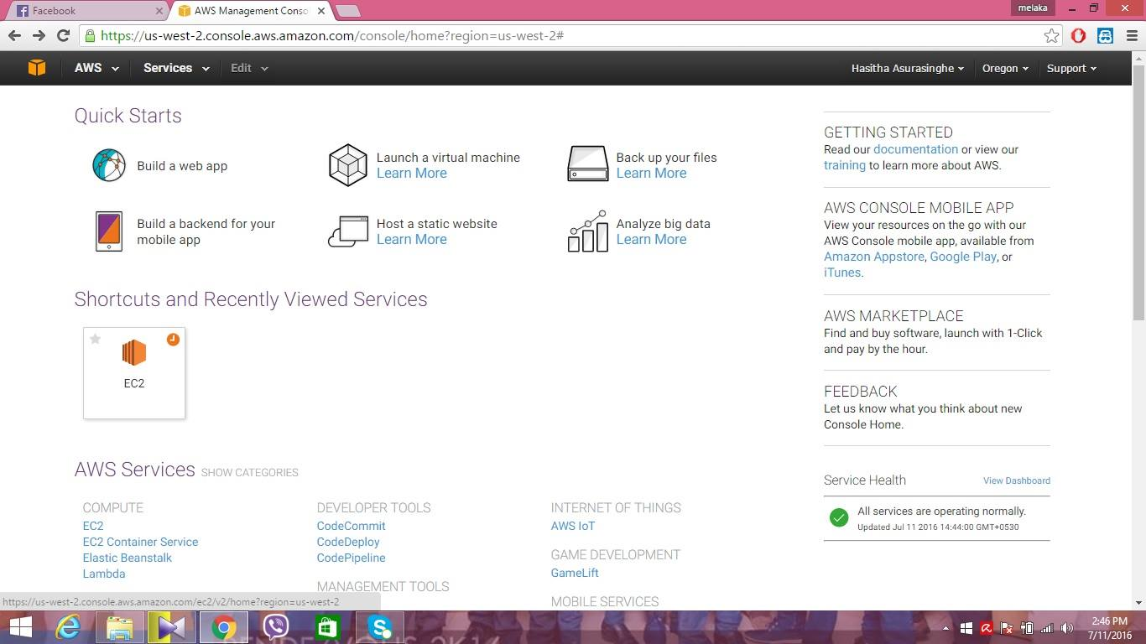

Step 03

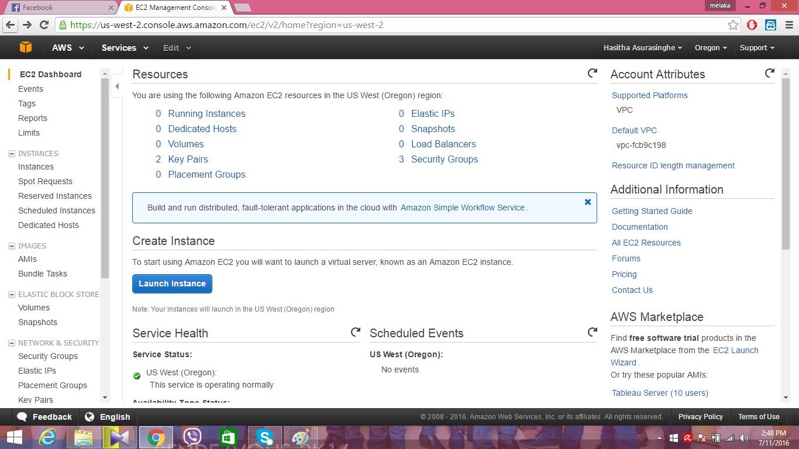Click the lunch instance which is under create instance.

Step 04

Select the Microsoft windows sever

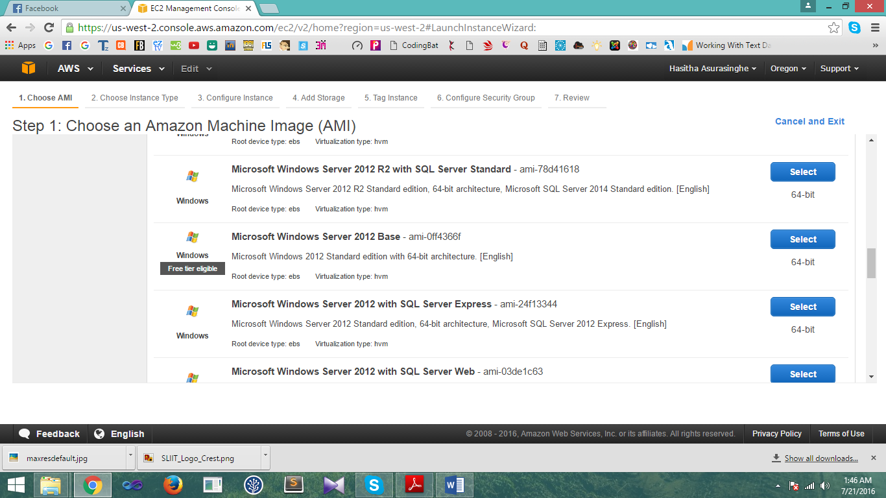

Step 05

Click the given default type and click the review and lunch button

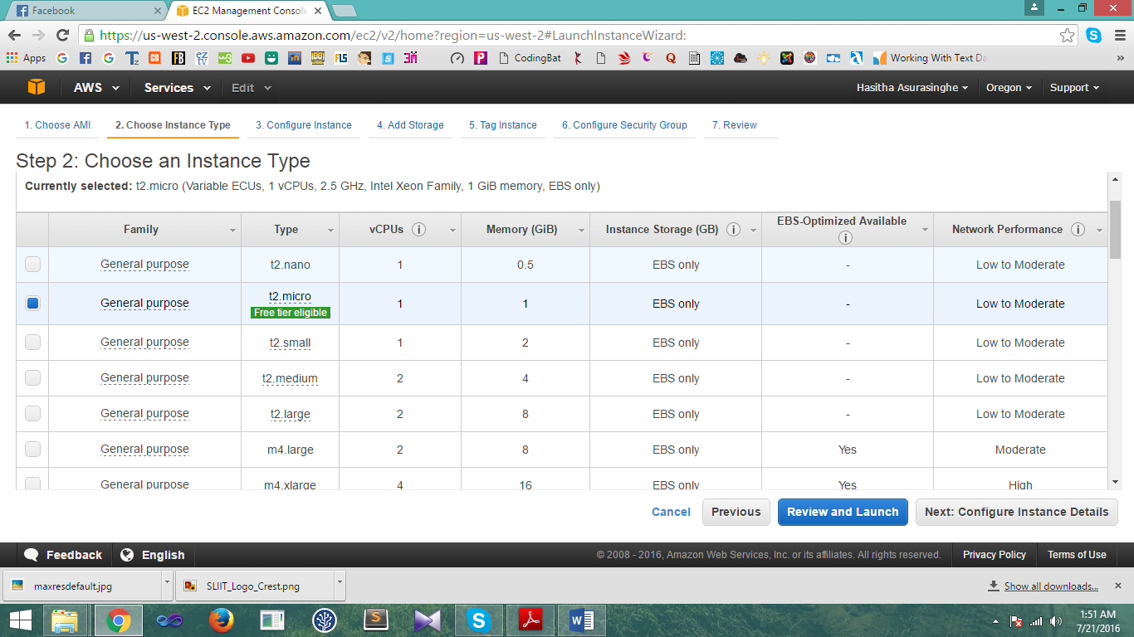

Step 06

Now review the instance. Click the lunch button.

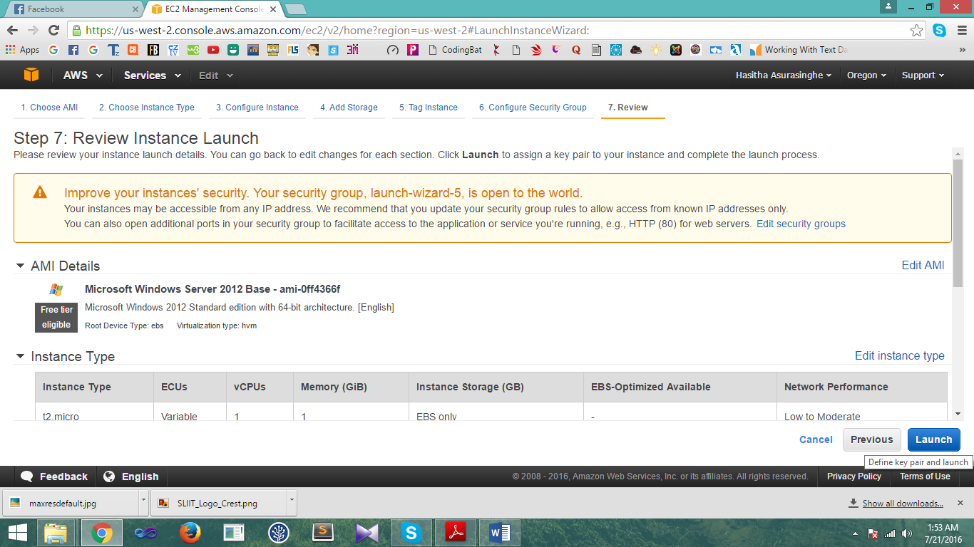

Step 07

User has to create a new key pair to lunch the newly created windows instance

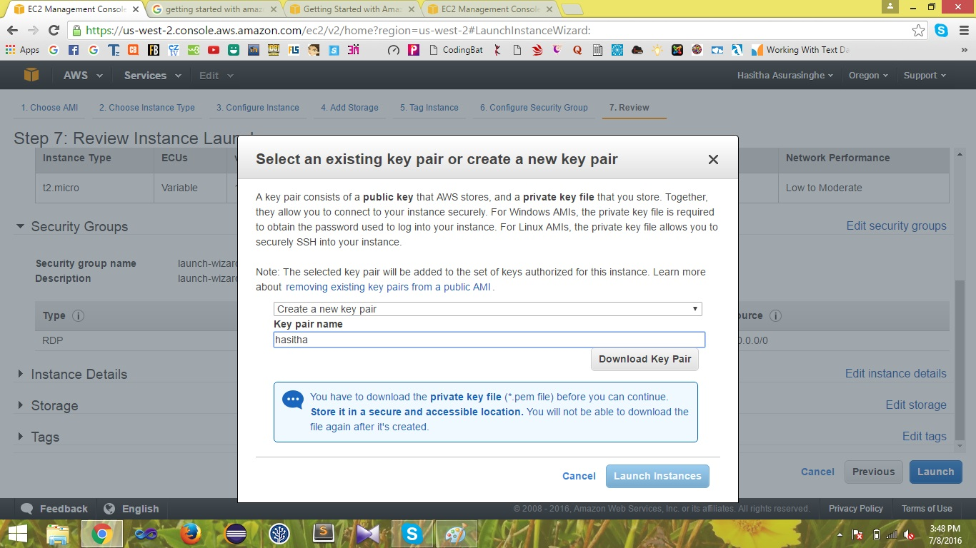Select “create a new key pair” from the drop down menu and give a new name for the key pair.

Step 08

Click “Download key pair” to download the key pair.



Step 09

Click on “lunch instance”

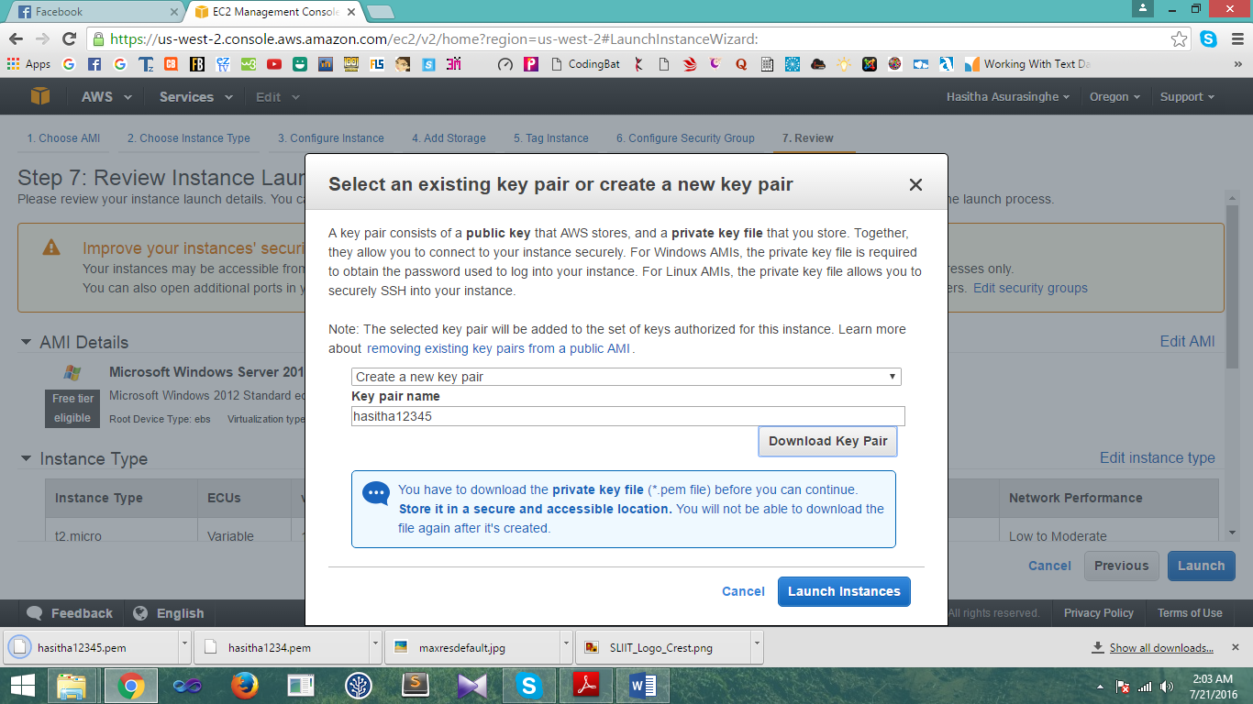

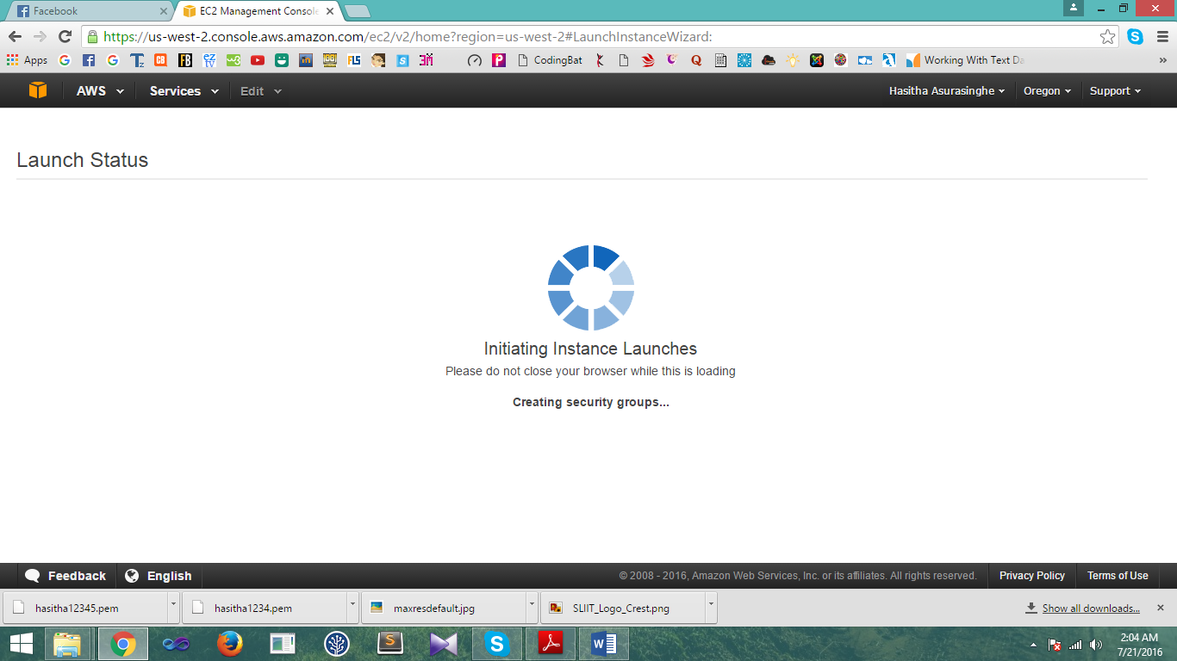

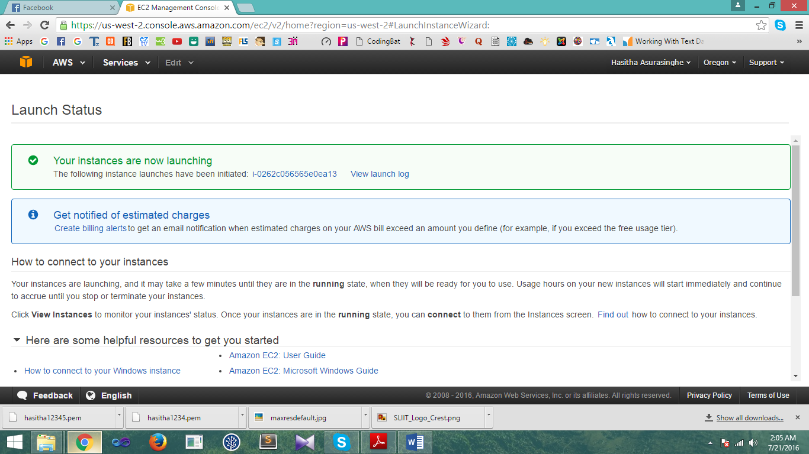

Step 10

Click on view instance

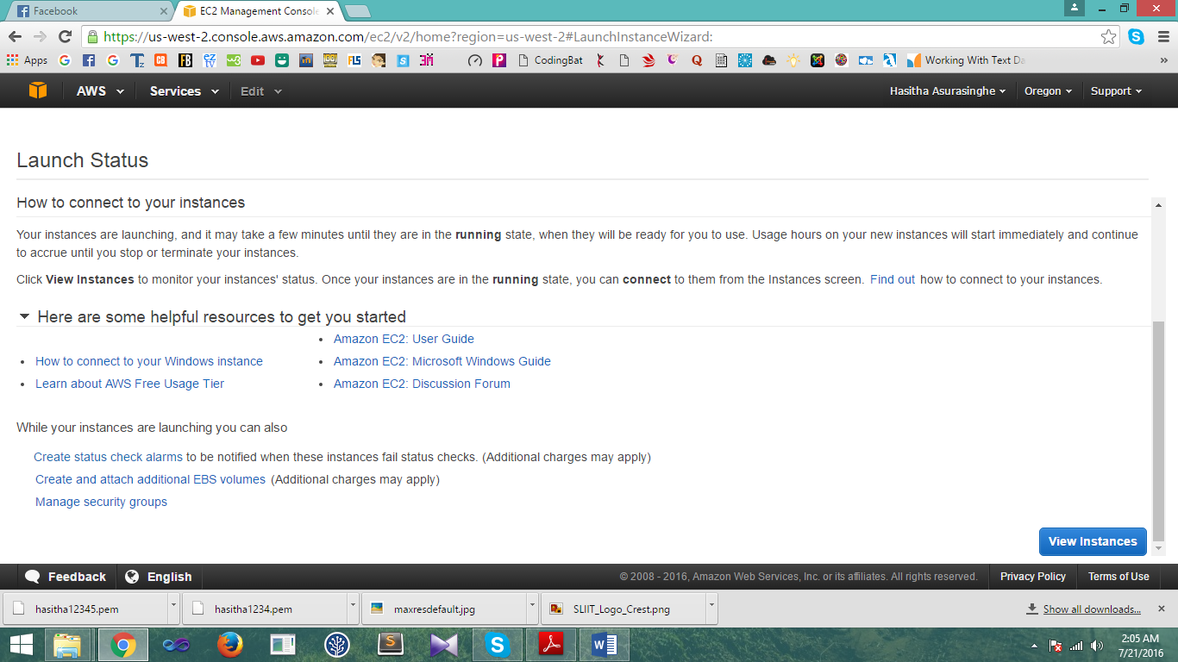

Step 11

Select the relevant instance.

Selected instance will be displayed in blue color.

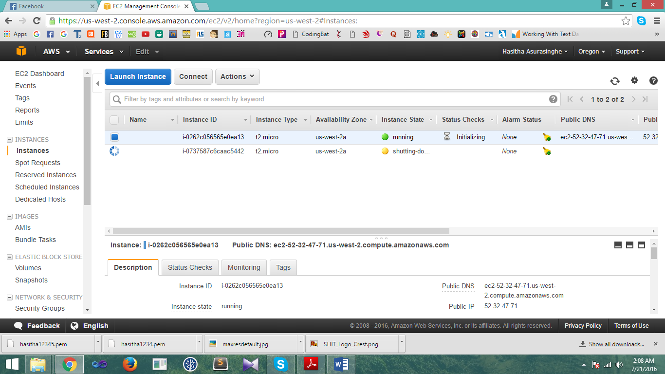

Step 12

Click “connect” button



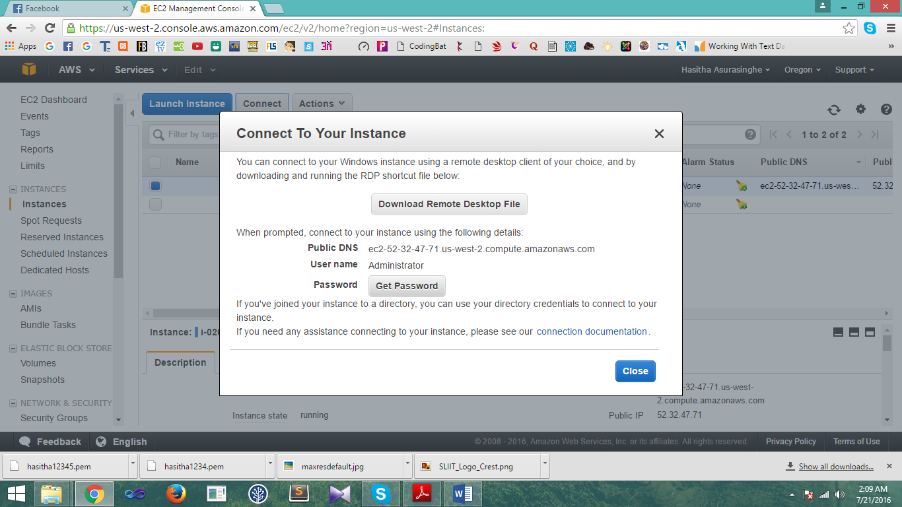



Step 13

Select the .pem file.

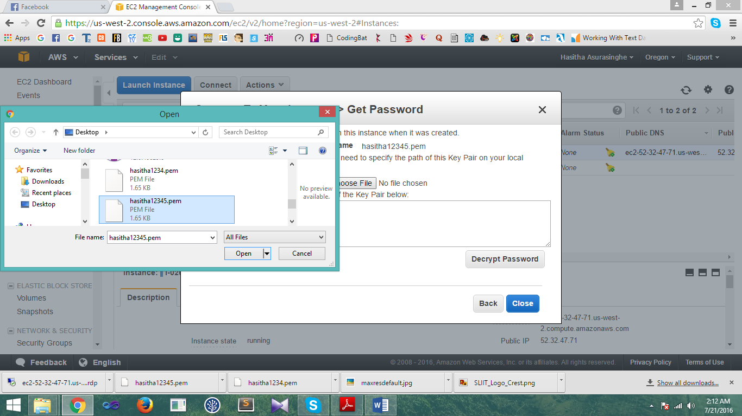

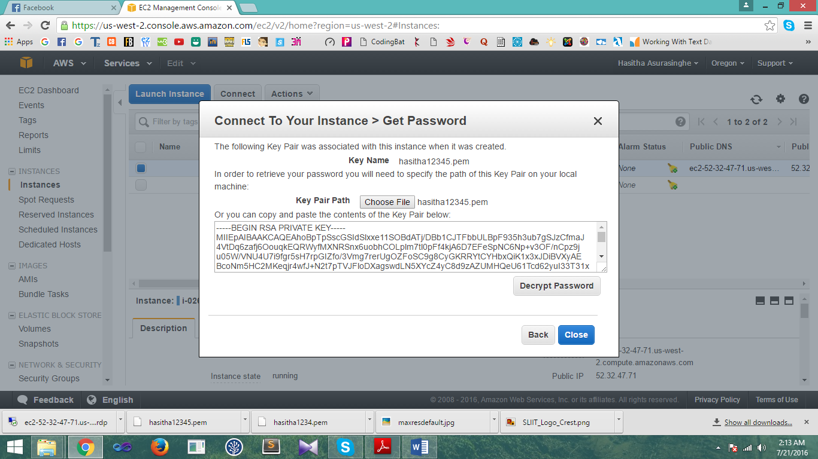

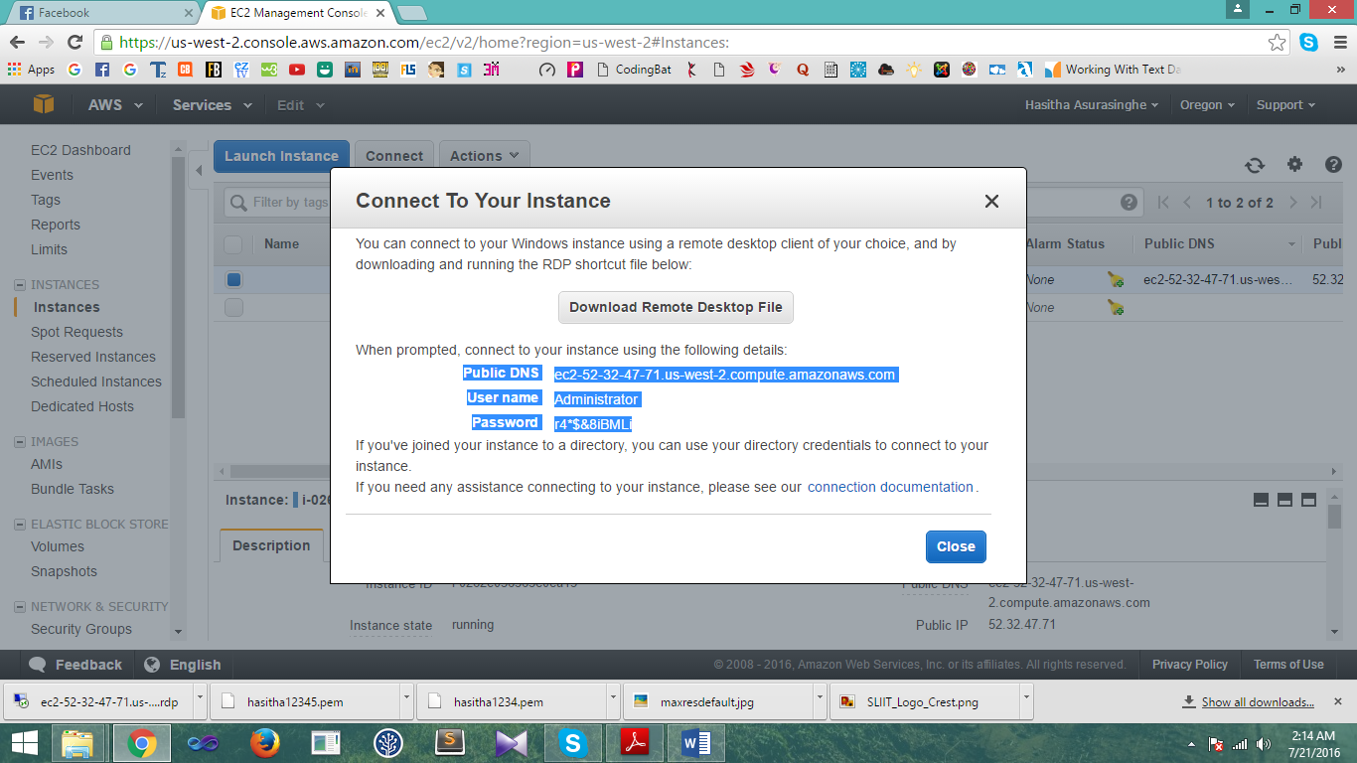

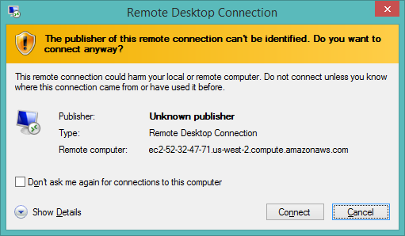

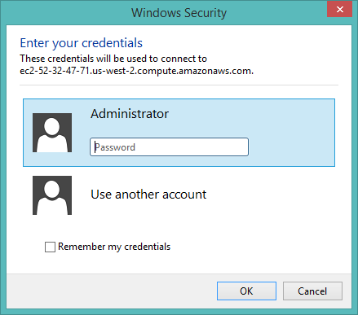

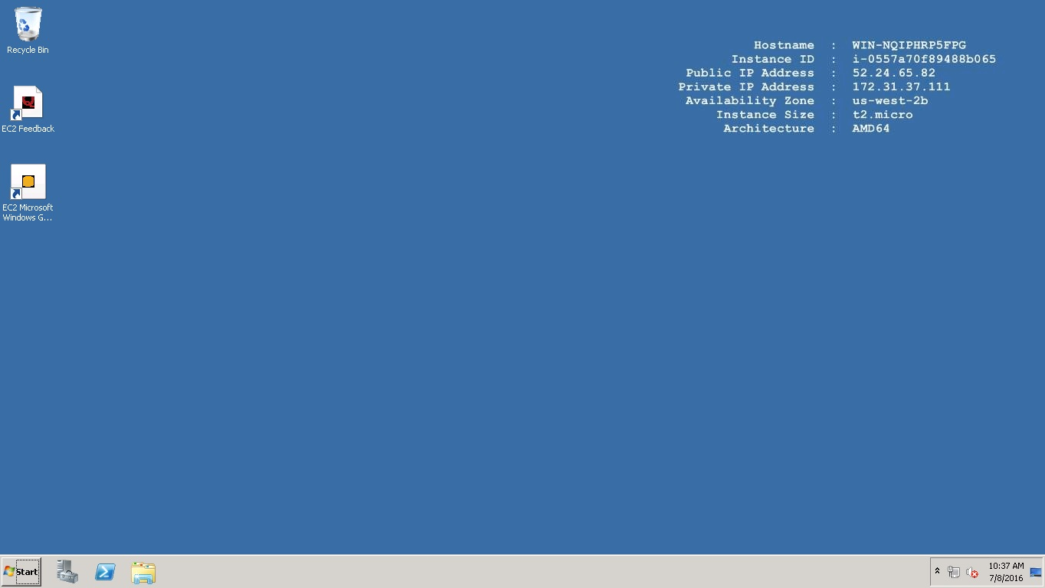

**02 Creating of linux instance using AWS Account**

Step 01

1. User has to loing to the AWS account.
2. User has to click the EC2 link .
3. User has to click the lunch instance button.







Step 02

Choose the “Amazon Linux 2016…”

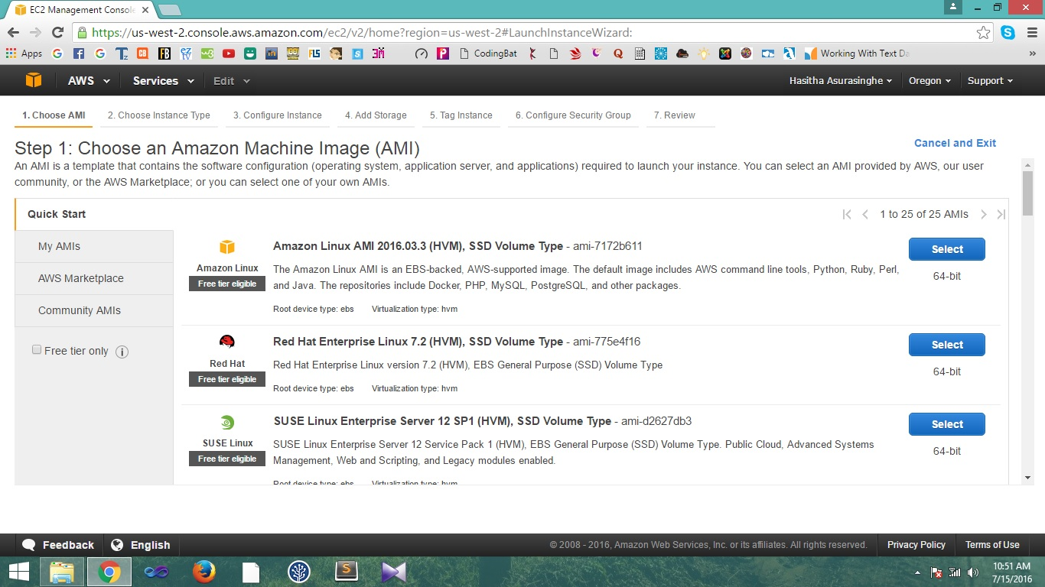

Step 03

Select the default row which is given in the table

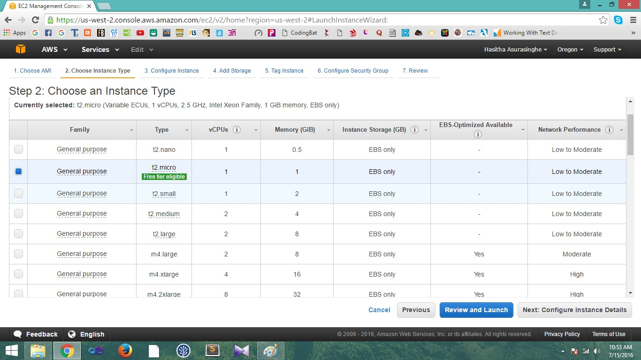

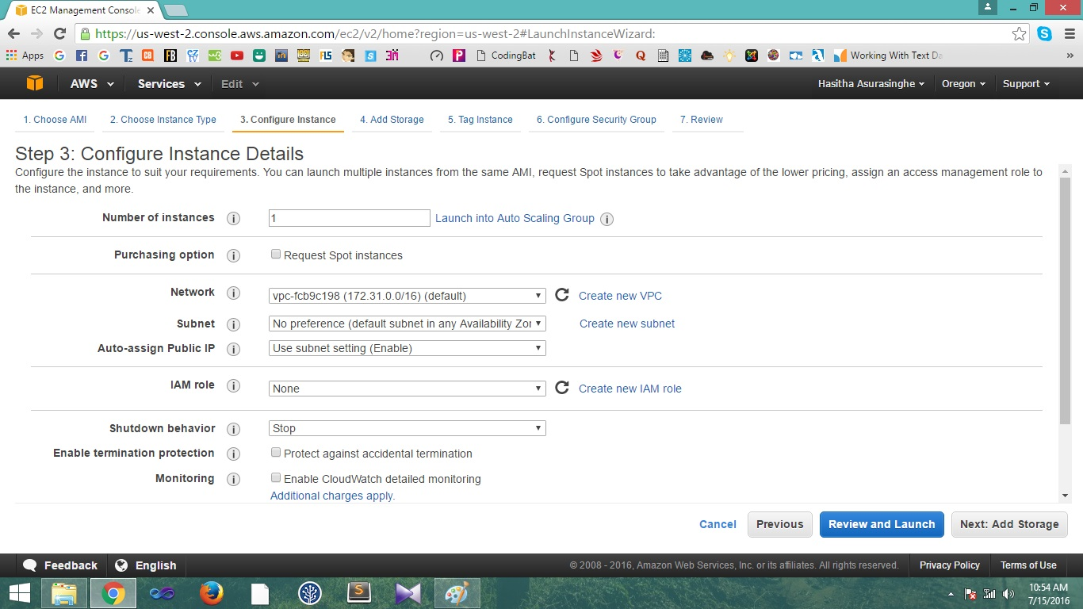

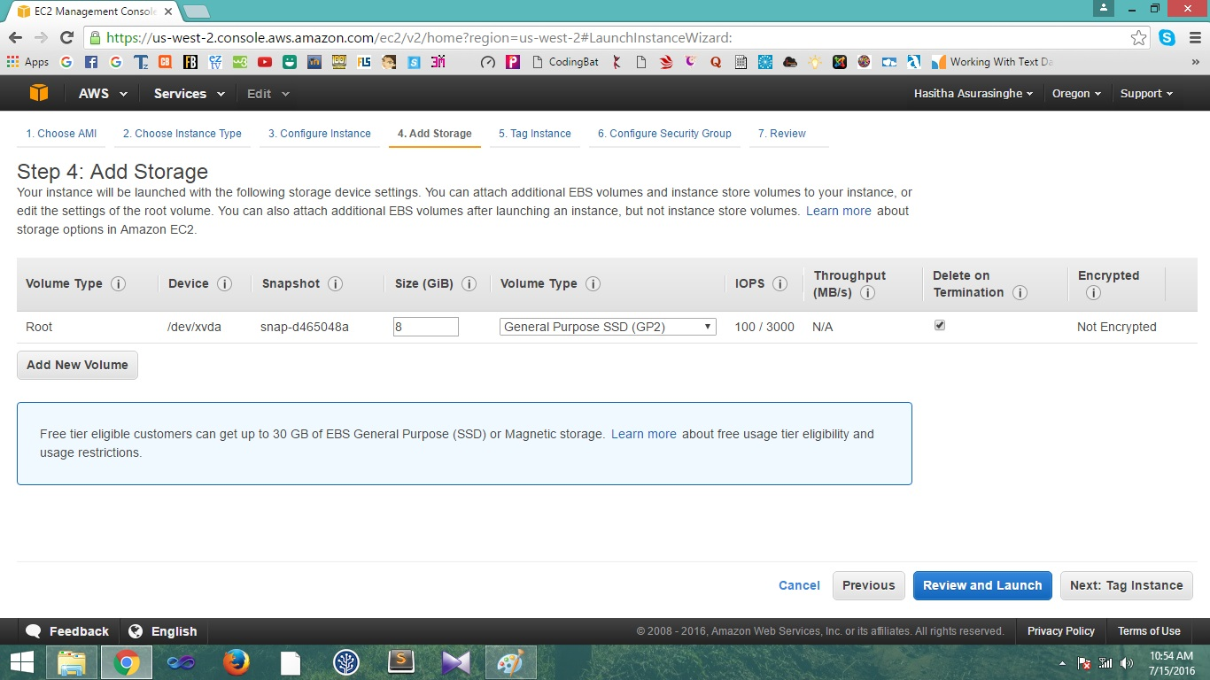

Step 04

Click the lunch button.

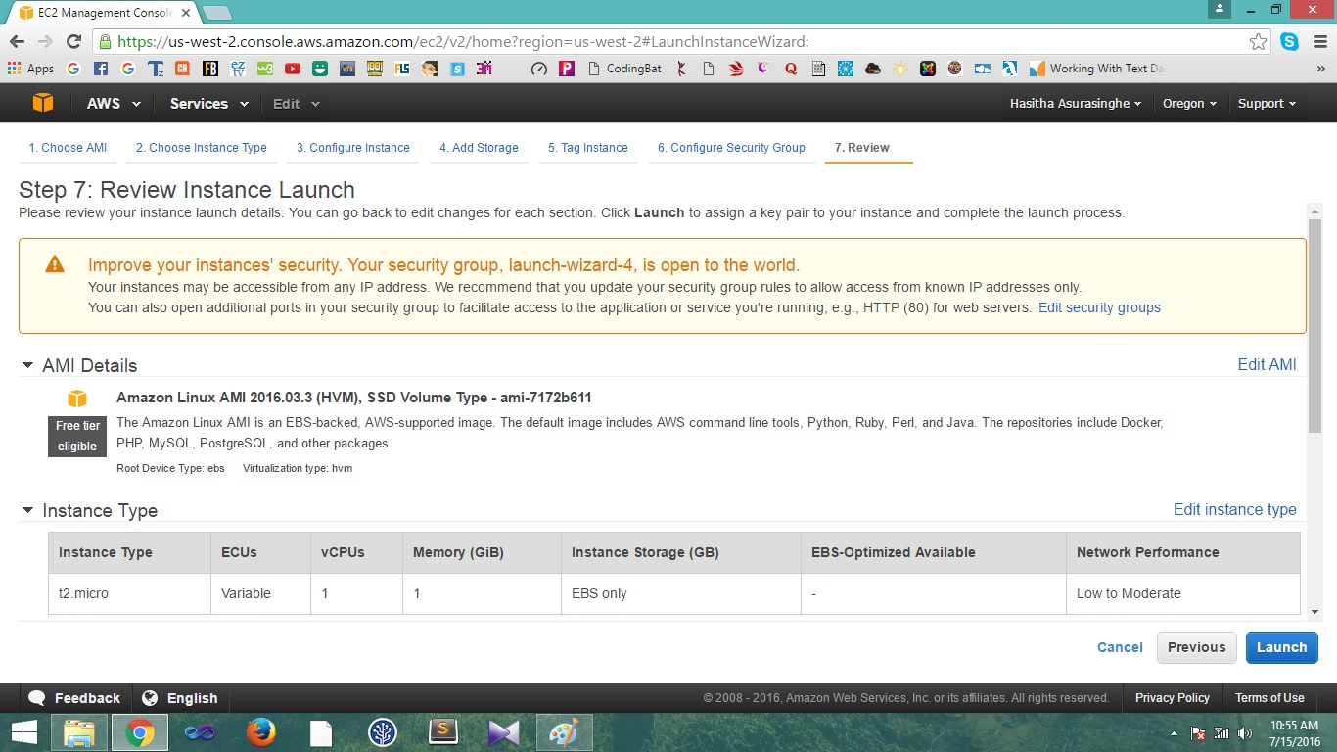

Step 05

Download the key pair and click “lunch instance button”

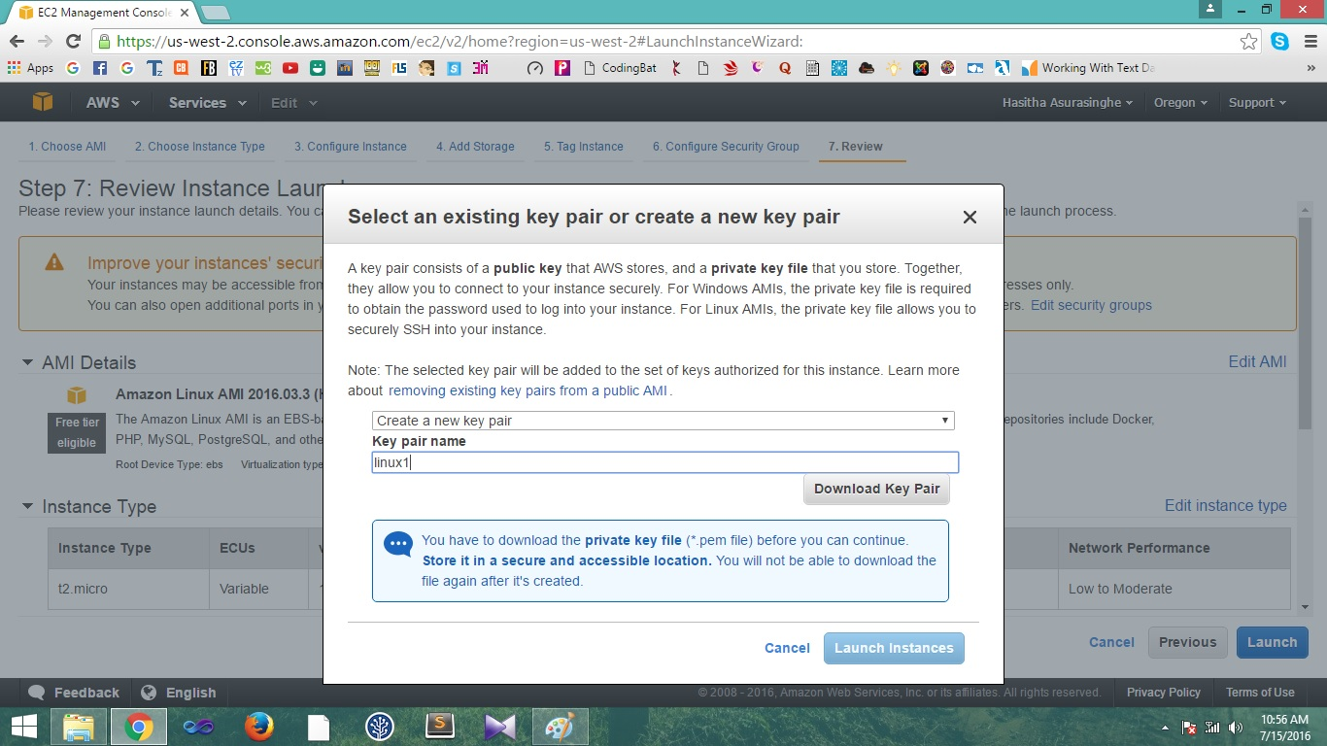

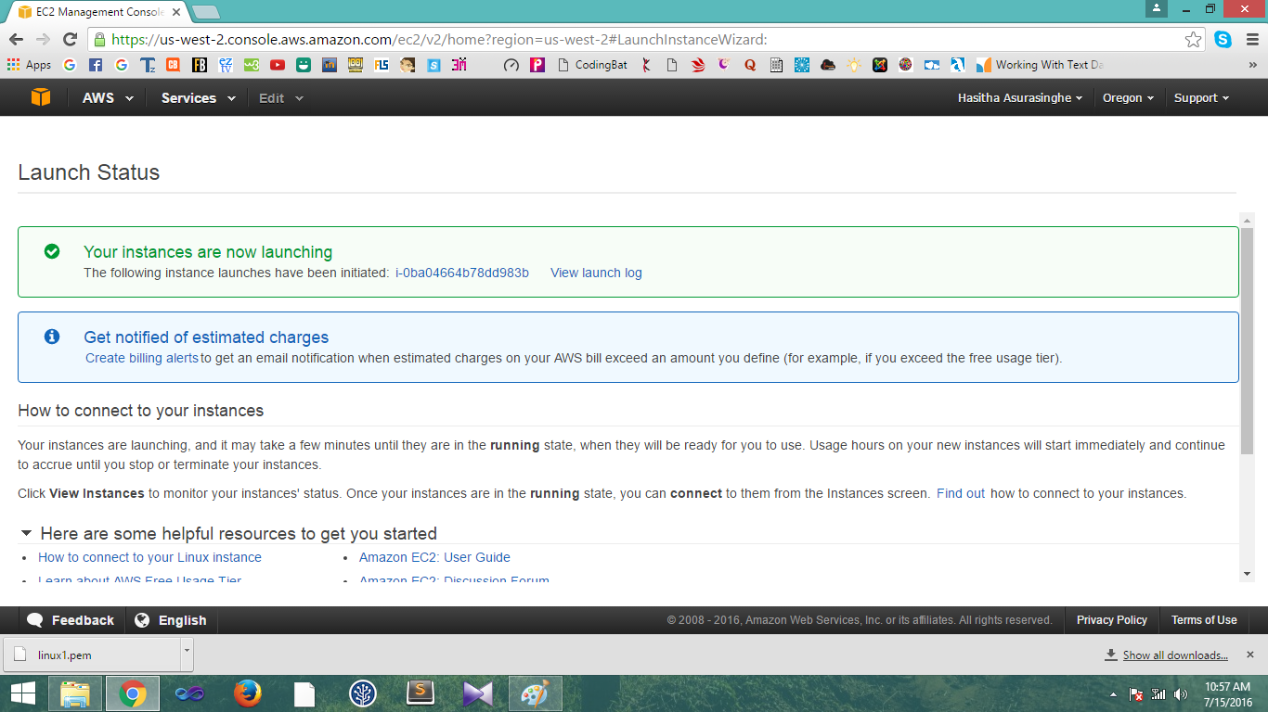

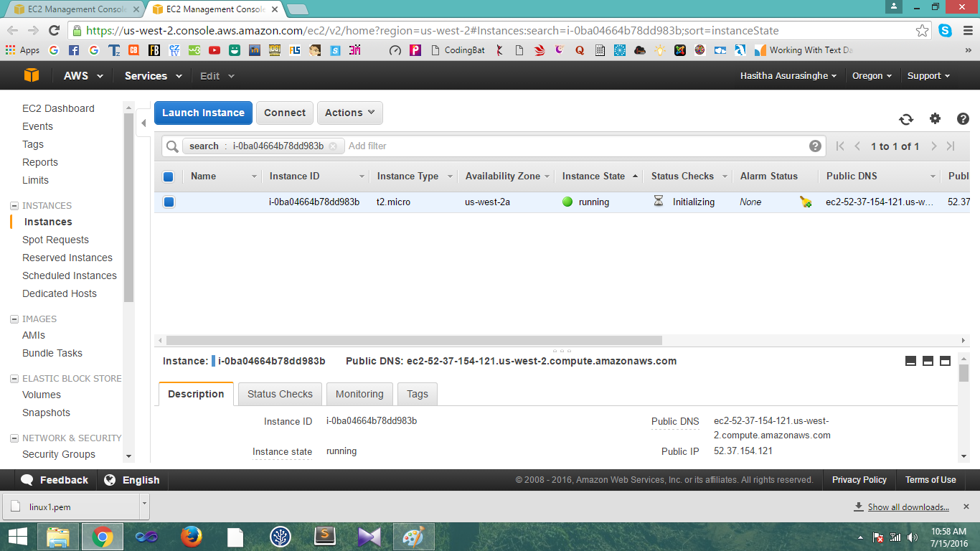

Step 06

Download “putty” and “puttygen” software

Step 07

Follow the steps bellow to configure the putty software

Open the puTTy Key Genetator software.

Click the “Generate” button

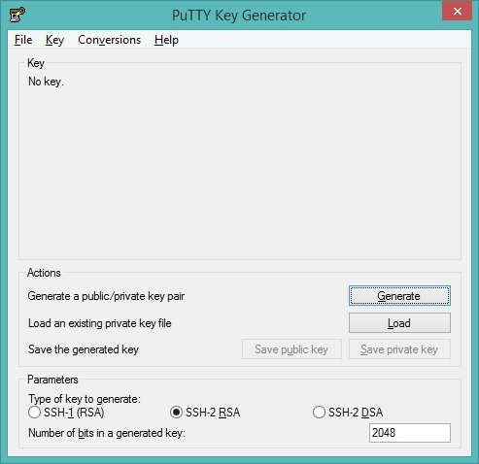

Click the “Save private key” button. And save the..ppk file.

Then click “save private key” button and it will convert it in to .pem file.

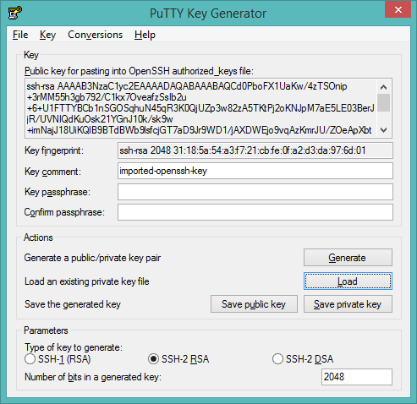

Step 07

Open the puTTY Configuration

And do the following

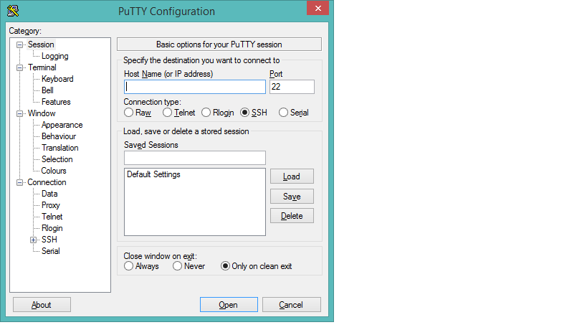



Copy and paste the above details in to Host name text box

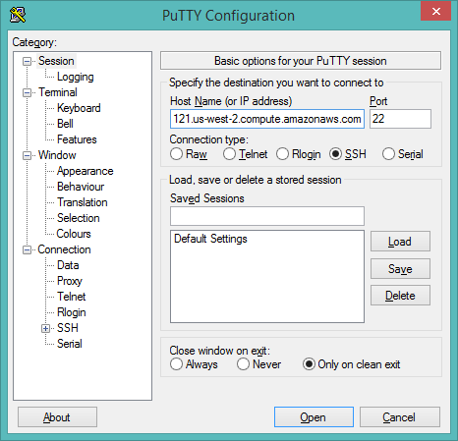

Click the browse button and load the linux.pptk file.

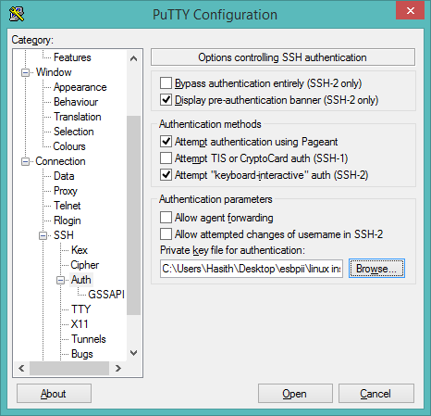

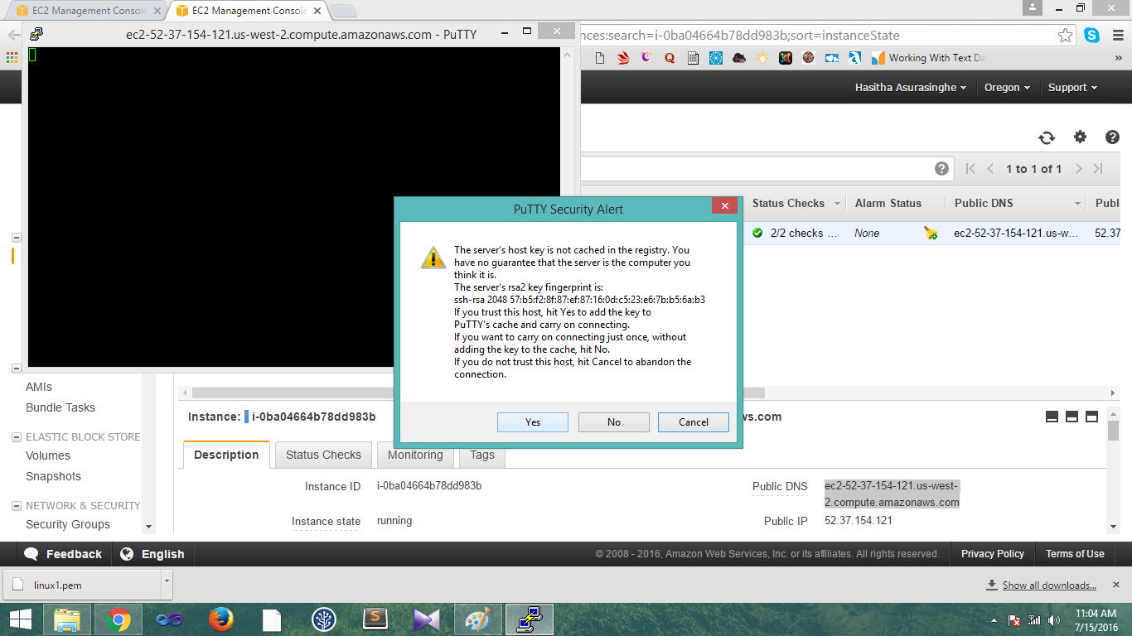

Step 08

Type the login details

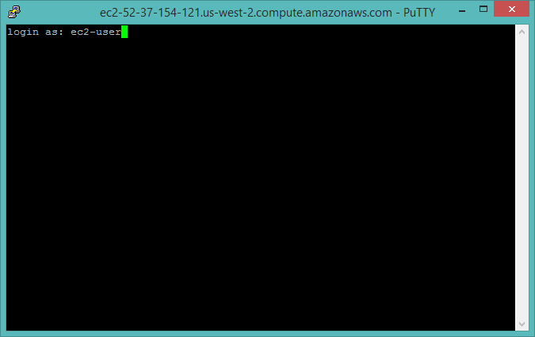

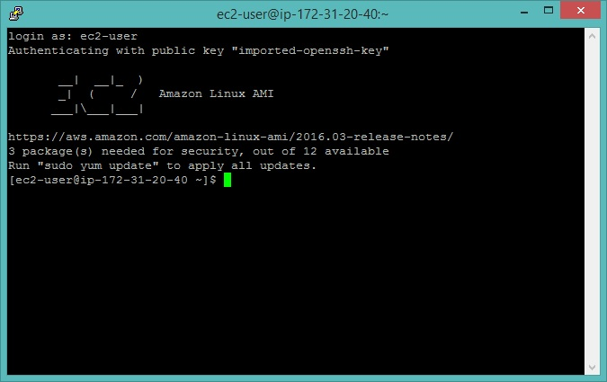

**03 Create DB instance using RDS.**

Step 01

Click on RDS button

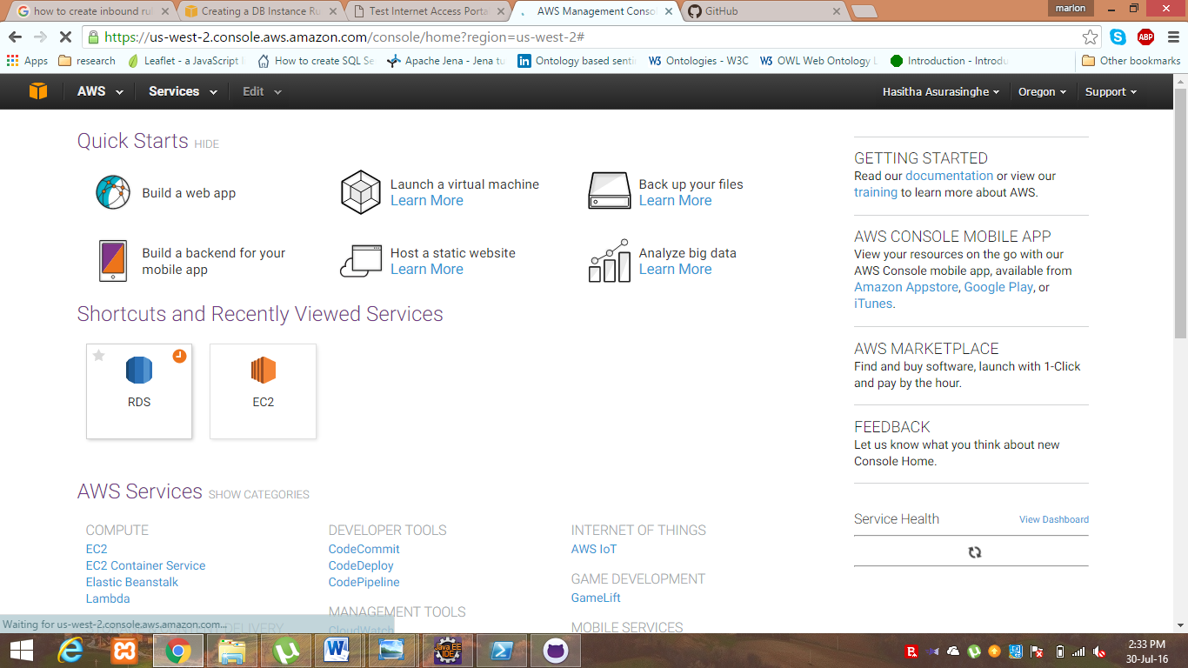

Step 02

Select MySql and click the select button

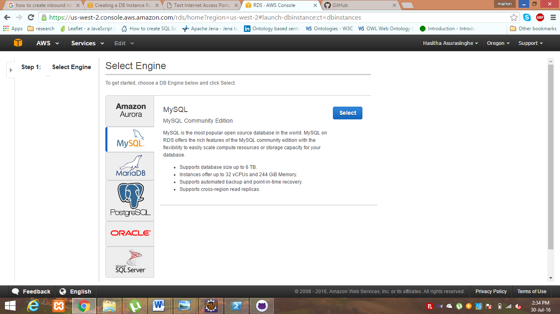

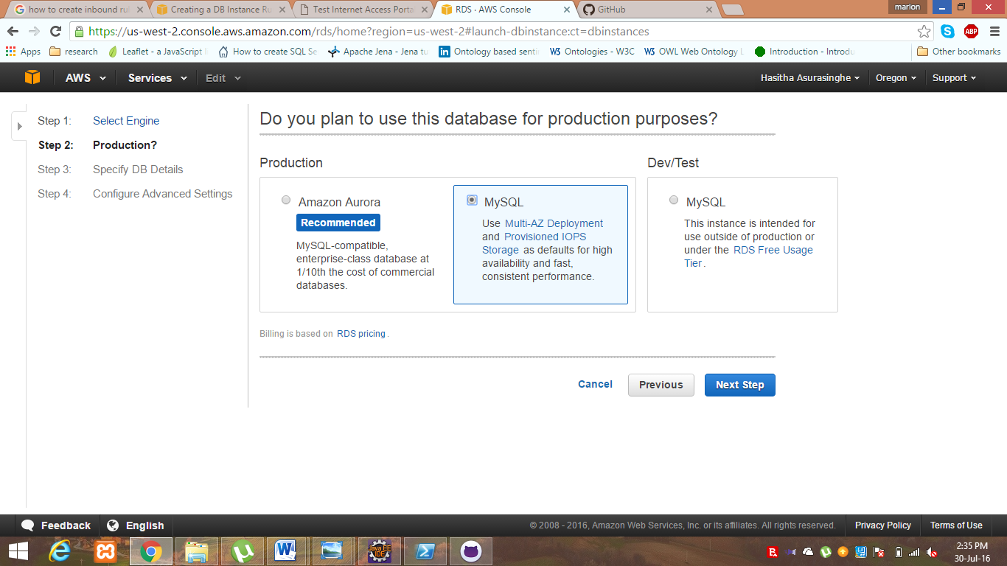

Step 03

Configure the settings given below

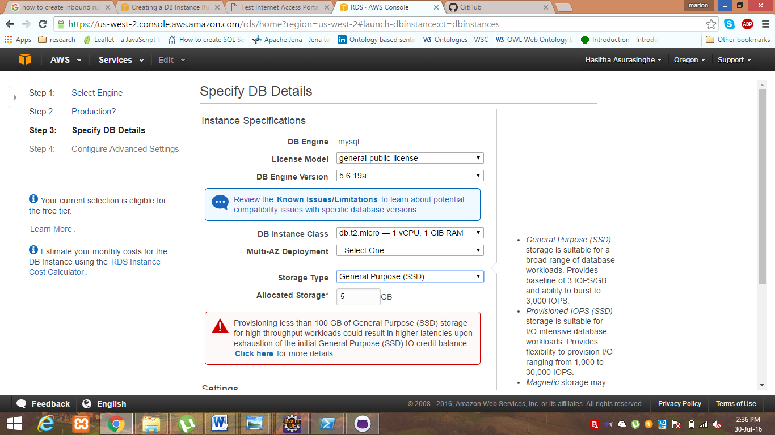

Click the “Next Step” button

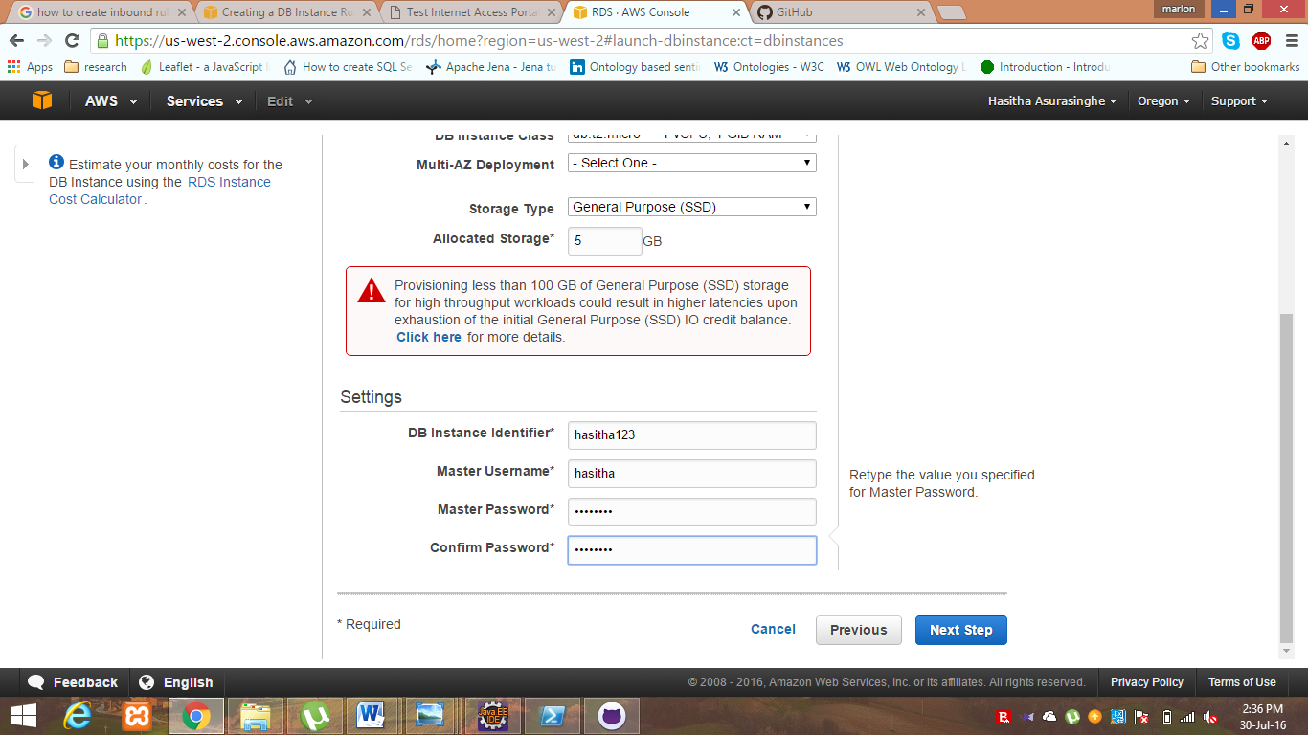

Step 04

Configure the settings given below

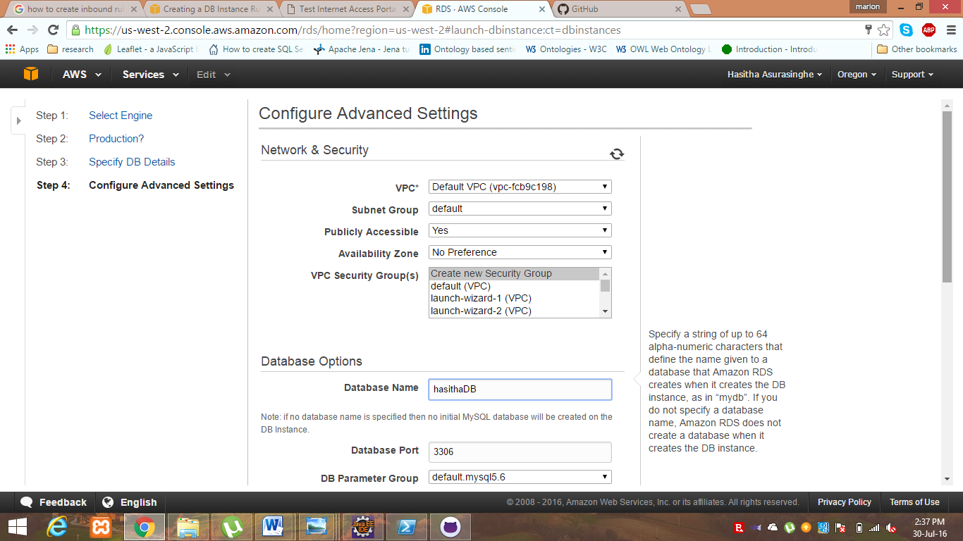

Click “Launch DB Instance” button

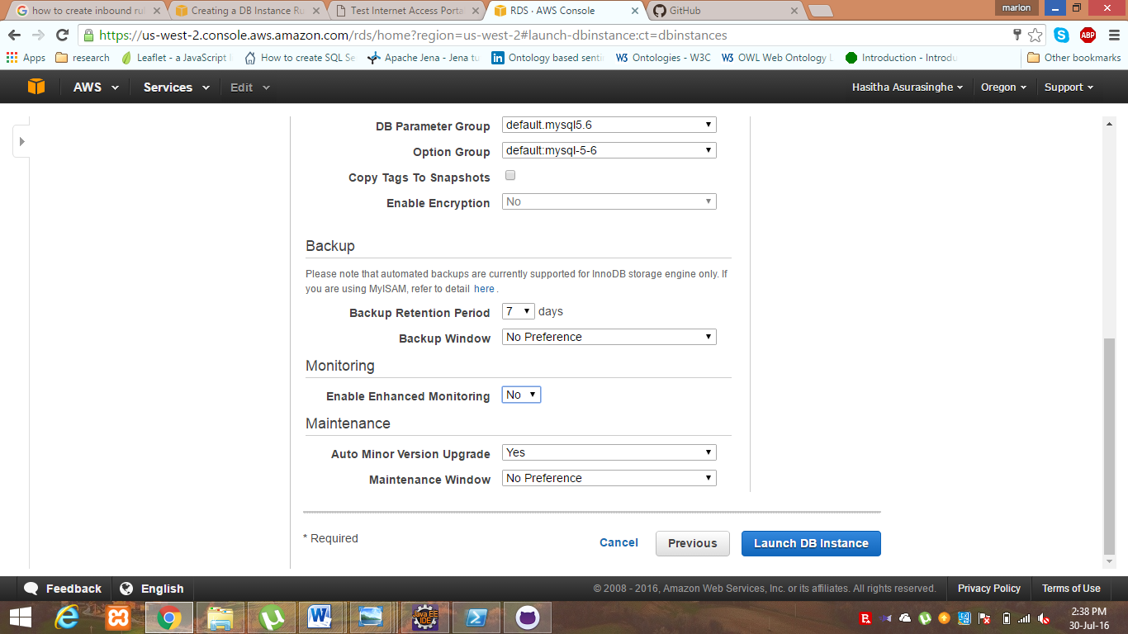

User can view the instance by clicking the “View Your DB instance” button

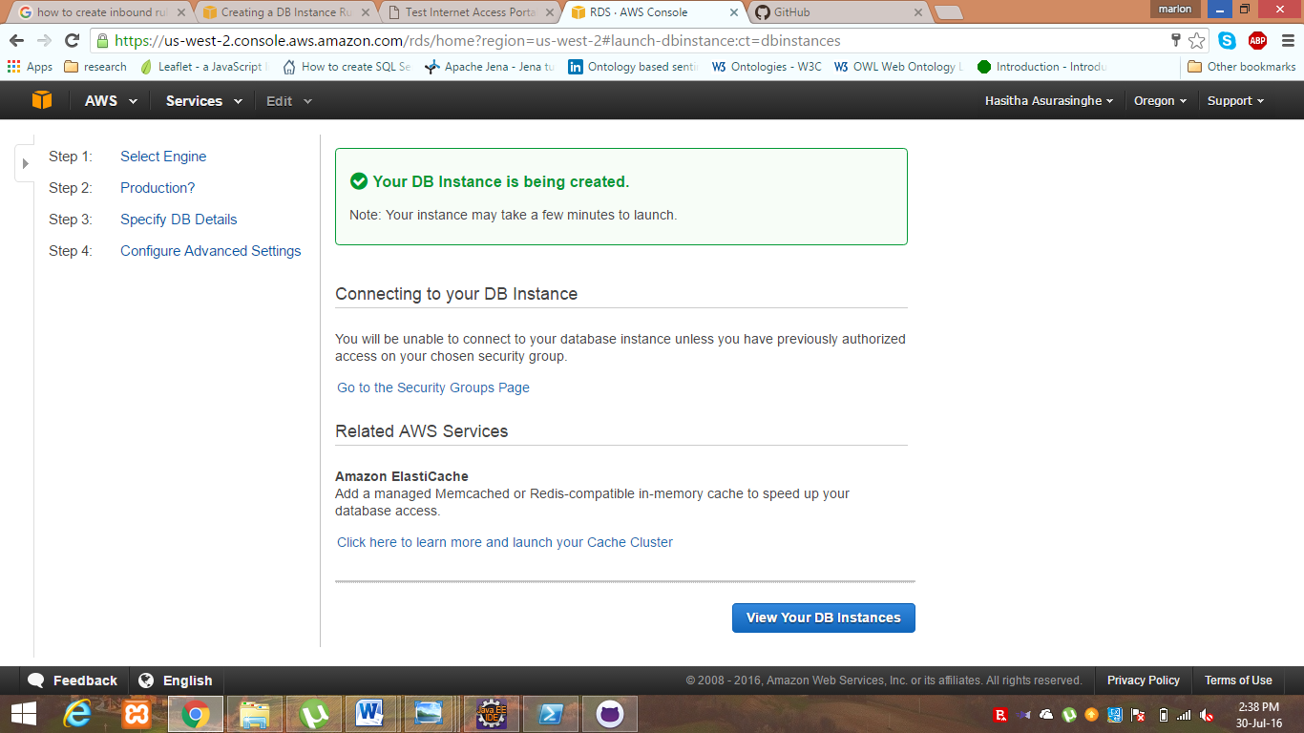

Step 05

User has to wait few minutes.

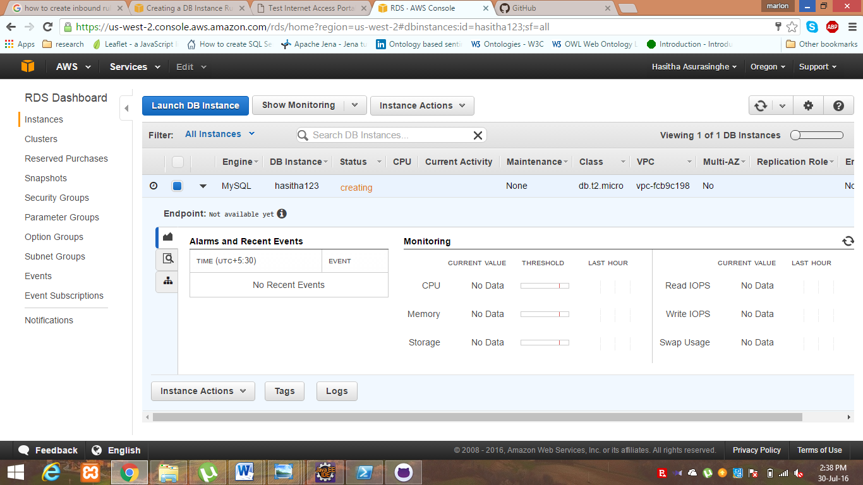

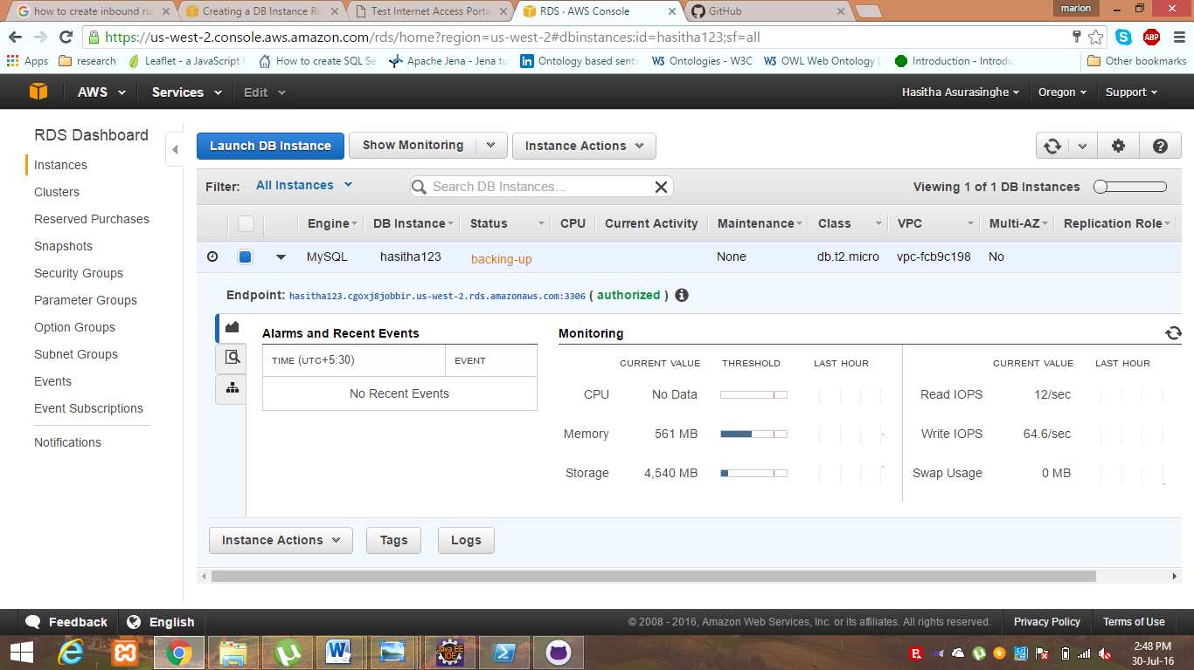

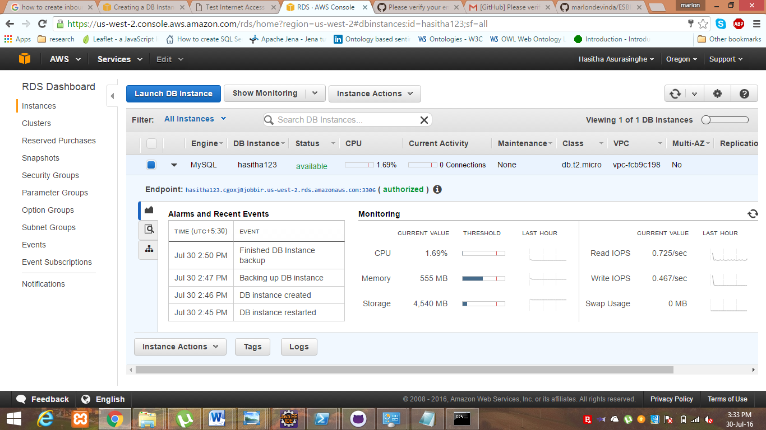

Finally user can login to the DB using the given user name and the password

